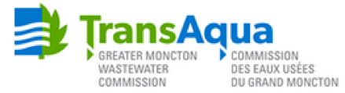

WWT Maintenance

Competition Number: 2019-01
Salary Range: $26.98 / hour as outlined in the GMWC – CUPE Local 5217 Collective
Agreement.
Job Type: Permanent Full Time
Closing Date: June 18, 2019

TransAqua serves the three area Municipalities of Moncton, Dieppe and Riverview with a major network of collector sewers, Wastewater Pumping Stations, a Wastewater Treatment Facility and a Composting Facility. TransAqua is responsible for the environmental stewardship associated with wastewater treatment, planning and regulatory requirements and is continuously supporting regional planning, economic development and quality of life for the communities of Moncton, Dieppe and Riverview. Its mission is “To collect and treat wastewater in a reliable, cost-efficient and environmentally responsible manner.” The Greater Moncton Wastewater Commission is an equal opportunity Emlployer that currently has a vacancy for a WWT Maintenance postion to begin full time employment on June 10, 2019.

Job Overview:

Reporting directly to the Manager – Liquid Systems while working with other Plant maintenance and electrical personnel and the management team, the WWT Maintenance postion is responsible for the general upkeep of equipment and facilities of the Wastewater Treatment Facility, Collector System, Composting Toilets and related equipment on the regular schedule as determined by the manager. As a secondary function, the Operator will do operational duties such as on-call operator rotations or other daily routine activities in maintaining & operating the plant effectively & efficiently.

This position, as does all team members, carries with it a responsibility to nurture, promote and champion TransAqua’s safety program.

Key Accountabilities:

- Respond/inform/coordinate actions required to address improper operations identified during daily checks or alarms generated by the SCADA;
- Monitoring of complete GMWC Collector System & Treatment Plant via SCADA
- All sludge dewatering via centrifuges when scheduled to do this task;
- Carry out inspection of the Wastewater Treatment Facility, Collector System, and Compost Toilets at a regular frequency and prepare checklist of items to be done;
- Start-up equipment and carry out inspection to verify proper functioning;
- Responsible for the following on dewatering days:
  - oversee sludge dewatering equipment;
  - capture information into log book;
  - condition and verify pH of sludge;
  - carry out process verification and quality assurance.
  - Set-up polymer system, replace bags and check proper functioning of system;
  - Start-up the dry lime feed system and verify proper functioning. Once process is stable, sample sludge at least once per day;
  - Ensuring conveyors are working effectively, cleaning of shipping shed; and
  - Ensure the liquid lime system is working properly.
- Ensure clarifier overflow weirs are clean;
- Maintain GORMAN RUPP dewatering pump and dewater clarifiers for the yearly mechanical maintenance;
- Note and report any deficiencies to your supervisor or manager;
- Assist maintenance personnel with emergency repairs if required;
- Oversee work by local contractors hired to carry out work for GMWC. Review daily timesheets and material usage and confirm (as required);
- Serve as duty operator on the regular on-call rotation schedule;
- Receive materials and chemicals as required;
- Provide guided tours of facilities as requested;
- Assist Laboratory technician with samplers repairs and collect samples if required;
- Tidy up facilities as per cleaning schedule;
- Assist other operations personnel in procedures & routine activities when required; and
- Oversee cleaning of clarifier overflow weirs, maintains scum hopper and dewaters clarifiers yearly in preparation for mechanical preventive maintenance.

Working Conditions:

Employees are required to work Monday to Friday between 8:30am and 4:30pm and scheduled and unscheduled overtime. At times incumbents perform strenuous physical labour for extended periods of time requiring physical strength and endurance. Other working conditions include lifting heavy loads, performing tasks in high or confined areas, moving on rough or unsteady surfaces, and making repetitive movements such as bending or lifting. Employees are exposed to a variety of weather conditions (e.g., rain, snow and extremes of heat and cold), construction sites, heavy traffic, vibration, noise, dust, chemicals, a variety of construction materials, paint, grease, oil, noxious odours, fumes and potentially hazardous materials.

Essential and Desirable Qualifications:

The preferred candidate:

- Post-secondary diploma in any trade or technical field is required; and
- A minimum 2 years of related industrial workplace experience.

The following certifications are considered to be an asset:

- Wastewater Treatment Operator Certification Level I;
- Wastewater Collection Operator Certification Level I;
- Emergency First Aid / CPR – Certification;
- Confined Space Entry Certification;
- WHIMS Certification;
- Fall Arrest Certification.
- Bilingual – French/English.

Qualified applicants should submit their resume by June 18, 2019 to:

TransAqua - Greater Moncton Wastewater Commission
355 Hillsborough Road
Riverview, NB
E1B 1S5
Email: krice@transaqua.ca
www.transaqua.ca

TransAqua’s Values & Competencies:
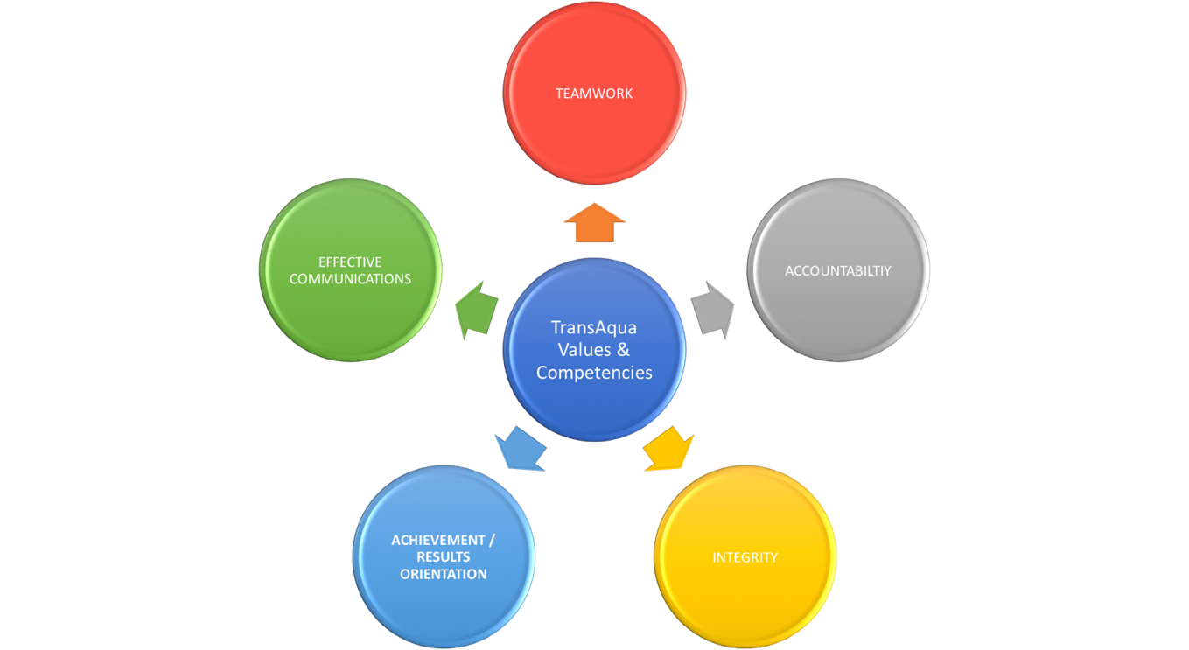

 | DEFINITION | INDICATORS
Teamwork | Working well with people is an absolute necessity. This is best accomplished with healthy debate and meaningful discussion to find the best conclusion and eventual decisions for forward progress. Teamwork and mutual respect for one another are essential to our success. | - Meeting challenges together  - Generation of ideas  - Working together  - Common goals  - Taking advantage of skillsets  - Valuing opinions  - Trust/Confidence in each other  - Co-creating RESULTS
Accountability | At the core of accountability is reliability and personal responsibility. Therefore, we value the ability of our staff and organization to work diligently and honor our commitments. We will also take responsibility for our work and promptly correct mistakes to the greatest extent possible. | - Getting things done  - Productive  - Doing what you’re supposed to do  - Dependable  - Responsibility for your actions  - Positive contribution to outcomes
Integrity | Integrity is the quality of being honest and having strong moral principles. Integrity comes in many forms, but the most important traits that we expect here are dependability, honesty, trustworthiness, respect, loyalty and good judgement. | - Doing the right thing when no one is watching  - Honesty  - Trustworthy  - Respect  - Genuineness  - Truthfulness (with yourself & others)  - Transparency

COMPETENCY | DEFINITION | INDICATORS
Achievement / Results Orientation | The ability to focus on achieving efficient, timely, quality results by directing efforts on expected outcomes, setting challenging goals, focusing effort on the goals, and meeting or exceeding them within expected timeframes. | - Develops challenging but achievable goals.  - Demonstrates an ability to focus time and effort on day-to-day goals and objectives.  - Maintains commitment to goals in the face of obstacles and frustrations.  - Finds or creates ways to measure performance against goals.  - Has a strong sense of urgency about solving problems and getting work done.  - Stays focused and balances changing or competing priorities and responsibilities.
Effective Communications | Openly communicating in a compelling, honest, persuasive and articulate manner, ensuring the message is clear, understood and consistent with TransAqua objectives. Exchanges ideas and willingly explores a variety of perspectives that respects unique individuals, audiences and circumstances. | - Listens and interprets verbal and non-verbal inputs in order to ensure thoughts and ideas are understood.  - Determines what information is to be communicated, when and to whom.  - Organizes a response based on an awareness of content and intended audience.  - Shares information, seeks feedback from others, and provides appropriate follow-up to ensure understanding of both the message and its intent.  - Expresses ideas respectfully and shares information in a clear and concise manner using the appropriate mode of communication.

